Lecture 2:

Visual Displays for Univariate Data – Cont’d (Section 1.2, page 8)

The Stem and Leaf Plot

Although a histogram tells us how many observations fall in a particular class, we lose information about the different values within a class.

A different method for displaying data which overcomes some of these difficulties, and which is easy to do, even by hand, is the Stem and Leaf Plot.

Recall that the position of an individual digit in a number tells us the value the digit represents. For example, consider the number 962.78. For this number 9 is 100’s digit, 6 is 10’s digit, 2 is 1’s digit, 7 is .1’s digit and 8 is .01’s digit.

The stem and leaf plot uses selected digits (called stems) to group the sample into classes. The individual observations are then represented by the stem and the next significant digit. This is called the “truncation” method.

EXAMPLE: Consider the following sample data of English Scholastic Aptitude Test (SAT) scores.

- 574 627 621 705 690 522 612 594 581 640 653 638 760 491

The data here ranges from 491 to 760. Thus it is reasonable to group the sample using the 100’s digit.

The number “638” is plotted as 6⏐3, (8 is truncated).

“6” is called a stem. The stem unit is SU=100 since the stem digit is the 100’s digit.

“3” is called a Leaf. The leaf unit is LU=10, since the leaf digit is 10’s digit.

6⏐3 = 630 approximates the actual value of 638.

Note: The leaf always consists of a single digit [anything more is truncated].

To illustrate these ideas, we plot the sample as follows:

- 574 627 621 705 690 522 612 594 581 640 653 638 760 491

Initial Plot: Stems Leaves

Final Plot: Stems Leaves

LU= ____________ , SU = _____________.

This plot is called one leaf category per stem plot (LCPS). The number of LCPS merely gives the number of lines for which the stem value is the same.

Example: Two leaf category per stem plot:

Stems Leaves

LU= _____________, SU= ________________.

Note: The increment of a stem and leaf plot is the distance from one line to the next.

INCR= SU/#LCPS

For the above example:

Describing Distributions (Section 1.3, page 24)

Continuous Distributions

Histograms of continuous data:

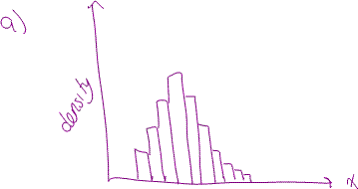

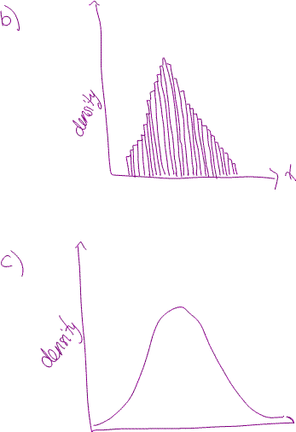

Definitions
A density function
is used to describe (at least approximately) the population or process distribution of a continuous variable
. The graph of
is called the density curve. The following properties must be satisfied:

.
(the total area under the density curve is 1.0)
For any two numbers a and b with
,

proportion of
values between a and b =
.

(This proportion is the area under the density curve and above the interval with endpoints a and b).

Notes: There is no area under the density curve above a single value. (e.g. above 2.5).

Prop. of x values satisfying 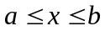 = prop. of x values satisfying 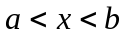

Example: A continuous variable x is said to have a uniform distribution if the density function is given by

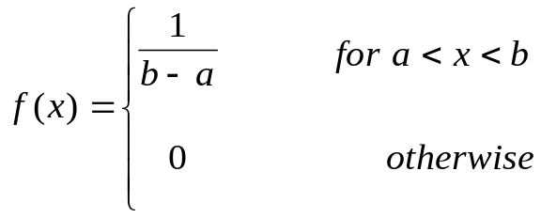

The corresponding density curve has constant height over the interval from a to b. At an ocean-side nuclear power plant, sea water is used as part of the cooling system. This use raises the temperature of the water that is discharged back into the ocean. The amount that the water temperature is raised has a uniform distribution over the interval from 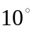C to 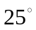C.
- Draw the density curve, and verify that the total area under the curve is indeed 1.

How do we verify that the total area under the curve is equal to 1?

- What is the probability that the temperature increase will be less than 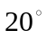C? Between C and 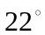C? At least 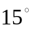C?

- What value separates the coolest 50% from the hottest 50% of all temperatures? (the median of the distribution)

- What value separates the coolest 10% from the remaining 90% of all temperatures?

Example: Shot-putters were asked to aim at a line 10 m away. They threw the shot 200 times and throws were measured within 2 m either side of the line. The results were gathered and a histogram was created. The investigator relates this to a continuous variable with density function 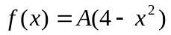 (where A is a constant) for 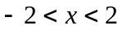, and 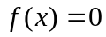 otherwise.

- Determine the value of A. Once you obtain the value of A, graph the function .

In Maple:
> with(plots):
> plot((3/32)*(4-x^2), x=-2..2, thickness=4, colour=[blue]);

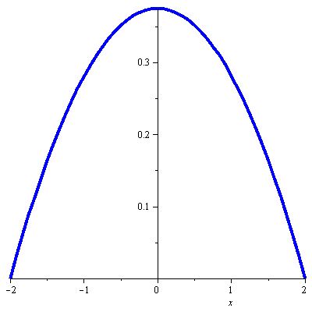

b) What proportion of shots are in front of the line by more than 1 m?

Exercise to try at home: What proportion of shots are behind the line by at least 0.75 m?

